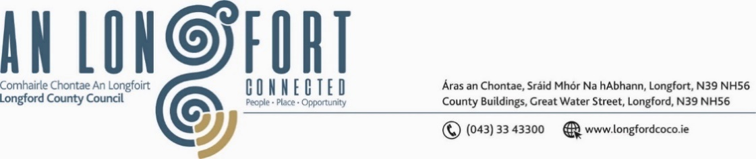

***GRANARD MUNICIPAL DISTRICT***

***Please note meeting will be held in Granard Library.***

**17 June 2024**

**To: Each Member of Granard Municipal District.**

A Chomhairleoir,

You are requested to attend the Annual Meeting of Granard Municipal District to be held in **The Council Chamber on Monday, 24 June 2024 at 2pm** to transact business, as set out on the Agenda hereunder.

Mise le meas,

______________

**Claire McNabola,**

**Meetings Administrator.**

**C L A R**

**1**.      Election of Cathaoirleach.

**2.**      Election of Leas Cathaoirleach.

**3.**       Nominations to Committees – referred from Longford County Council

          2024 Annual Meeting

**4**.      Standing Orders of Granard Municipal District meetings.